DATABASE DESIGN
(GROUP – 13)

- OVERVIEW
The database has five tables, built around one core idea: a user logs individual expenses, each attached to a category; separately, they set a budget for each month; and the system compares the two to generate alerts. Everything connects back to USERS.

- ENTITY-RELATIONSHIP DIAGRAM
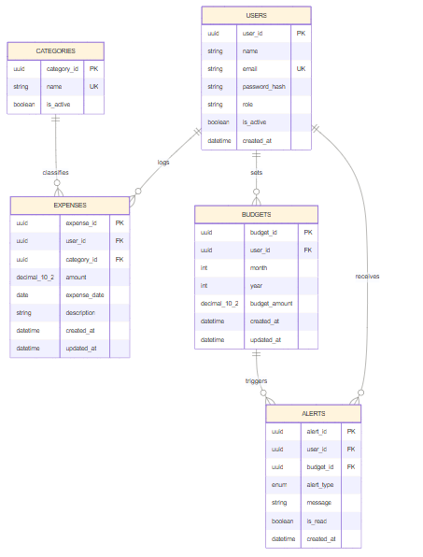
- TABLES
USERS | Every person using the app i.e., regular users and admins share this table, distinguished by a role field. Holds identity info: name, email, hashed password, and an is_active flag.
CATEGORIES | The fixed list of spending categories (Food, Travel, Rent, etc.), managed by admins. Kept as its own table so the admin can manage the list centrally without touching old expense records, and to avoid inconsistent free-text entries.
EXPENSES | The core transactional table. Every logged spend is a row here: amount, date, description, which user, which category. This is the busiest table most queries (monthly totals, prediction input, reports) run against it.
BUDGETS | One row per user, per month, per year so a user has a separate March budget and April budget, each with its own amount. This design keeps full month-by-month history instead of a single overwritten value.
ALERTS | System-generated notifications: 80% budget warning, 100% exceeded, or a predictive warning. Linked to BUDGETS optionally, since predictive alerts can fire based on spending trends before a threshold is technically hit.

- RELATIONSHIPS
- One USER → many EXPENSES (a user logs dozens of expenses over time)
- One CATEGORY → many EXPENSES (many transactions can share a category, e.g. “Food”)
- One USER → many BUDGETS (one budget row per month)
- One USER → many ALERTS
- One BUDGET → many ALERTS (a single month's budget can trigger both an 80% warning and later a 100% exceeded alert)

- KEY POINTS
DECIMAL(10,2) for money, not float | Floating-point introduces rounding errors with currency; decimal is exact.
UNIQUE (user_id, month, year) on budgets | Physically prevents two budget rows for the same user in the same month — enforced by the database itself.
alert_type as ENUM / CHECK, not free text | Stops typos like “Warning80” vs “warning_80” from silently breaking alert logic.
Soft delete (is_active) instead of hard delete on users | Deactivating a user must not destroy their expense history needed for reporting/audit.
ON DELETE RESTRICT on foreign keys | Backs up the soft-delete decision — database refuses to delete a user row while expenses reference it.
updated_at on expenses & budgets | Requirements allow editing expenses; need a record of when something last changed.
Indexes on user_id, category_id, expense_date | These columns are filtered/joined on constantly (monthly totals, category breakdowns) — indexes keep queries fast as data grows.

- SUMMARY
Users log expenses tagged by category; each month they set a budget; the system compares actual spend against that budget and raises alerts. The schema is normalized so nothing is duplicated, and every constraint (unique budgets, decimal precision, restricted deletes) exists to prevent a specific real bug.

